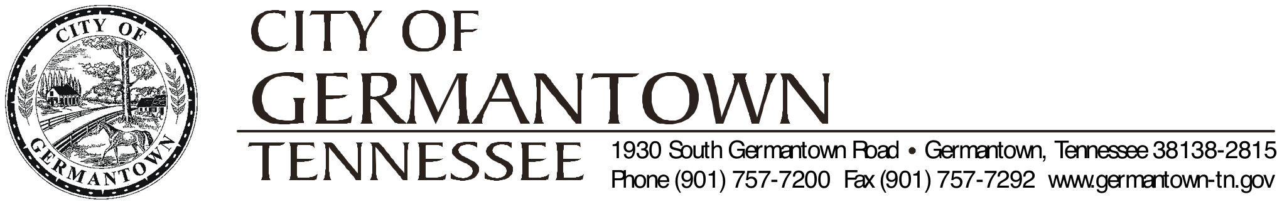

Senior Advisory Commission
Thursday, March 15, 2017 – 3:30pm
Parks and Recreation Offices Conference Room
2276 West Street

Chairman -James Debo Alice Wallace Bettye Weathersby
John Hicks Irv Hyman Jayu Wagh
Charles Clark Wynn Bellerjeau Thom Parzinger Alice Clare Colville Larry Unterberger
Alderman Liaison – John Barzizza

Agenda

- Call to order

- Roll Call /Establishment of Quorum

- Consideration of Minutes
- Approval of the February 15, 2017 Minutes

- Old Business
- Discuss 2018 Spring Seminar

- Discuss Summer Programs

- New Business:

- Announcements and Save the Date:
- 2018 Spring Seminar - Alzheimer’s Disease and Prevention April 12, 2018
from 9:30 – 11:30 a.m.

- Adjournment
- Our next official meeting will be on Thursday, April 19, 2017 @ 3:30 p.m.

